- Access GCP at https://console.cloud.google.com/iam-admin/serviceaccounts
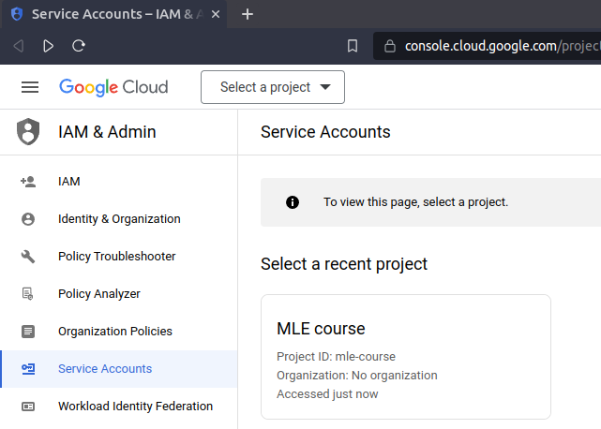
- Select MLE course (feel free to select your project if it differs from mine). After that, you’ll see something like this, click + CREATE SERVICE ACCOUNT
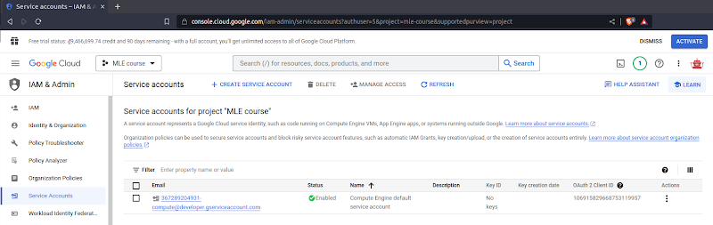
- Fill in the information similar to this, and click CREATE AND CONTINUE
the 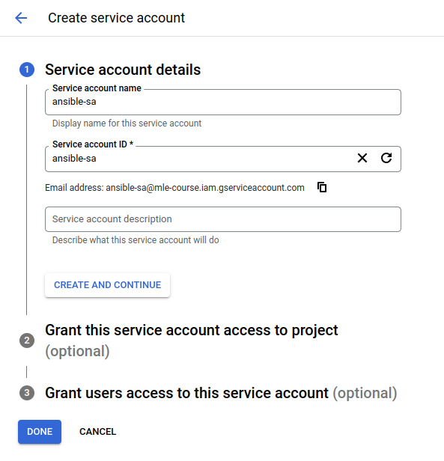then attach Role Compute Admin, then click the blue button DONE
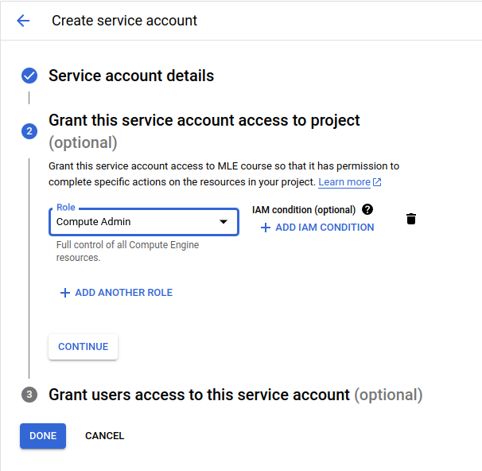
- GCP will navigate you back to the Service Accounts section, and you should see ansible-sa displayed as follows
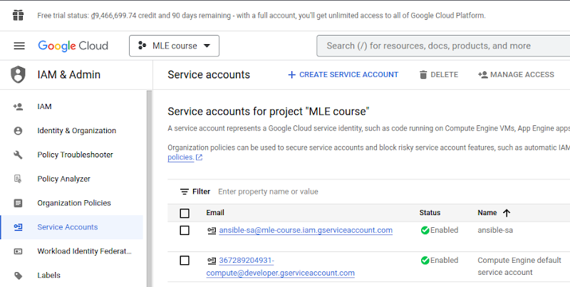
- Find the 3 dots button in the Actions column of the service account ansible-sa and click Manage keys
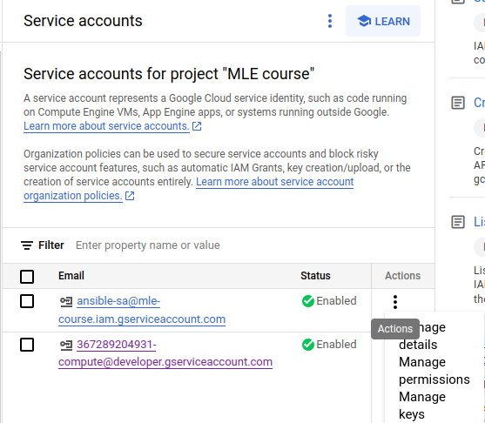
- Click ADD KEY, then Create new key
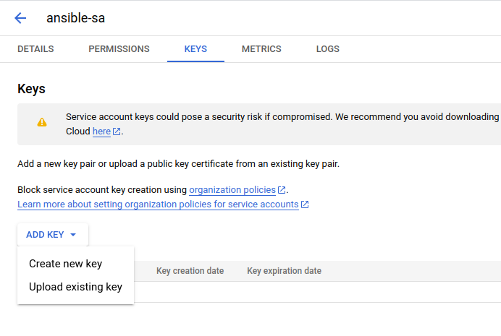
- Click CREATE to download a JSON file. Please keep this file SAFE. Put your credentials under the folder `iac/ansible/secrets`
